**Building Delivery Pipeline as Code**

In this demo we will be establishing a build pipeline which will implement complete CI/CD pipeline for delivering the source code to tomcat apache environment.

This demo will be divided in mainly three components:

1. Setting up JDK and maven build tool
2. Tomcat apache installation
3. Preparing Jenkins pipeline script and then configuring in Jenkins application

**Setting up JDK and Maven build tool**

First we need to install basic build tools to automate the build procedure. Install JDK and maven build tool on Ubuntu server using below set of commands.

apt install openjdk-8-jdk maven

java -version

mvn --version

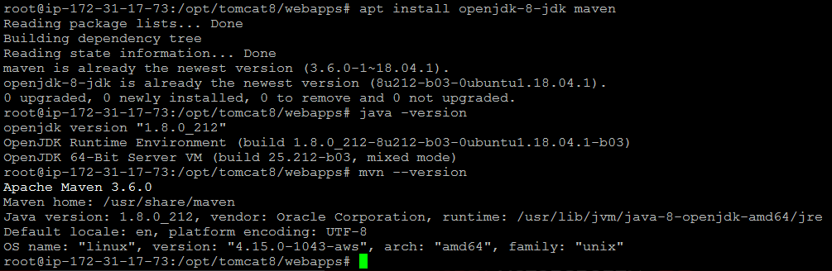

**Tomcat Apache Installation**

Follow below set of commands to install tomcat apache in our Ubuntu server using below set of commands. We are using tomcat apache as and web server where we will be deploying our source code using Jenkins pipeline script.

cd /opt

mkdir tomcat8

cd tomcat8/

wget http://apachemirror.wuchna.com/tomcat/tomcat-8/v8.5.42/bin/apache-tomcat-8.5.42.tar.gz

tar -xzf apache-tomcat-8.5.42.tar.gz

mv apache-tomcat-8.5.42/* .

chmod -R 777 webapps/

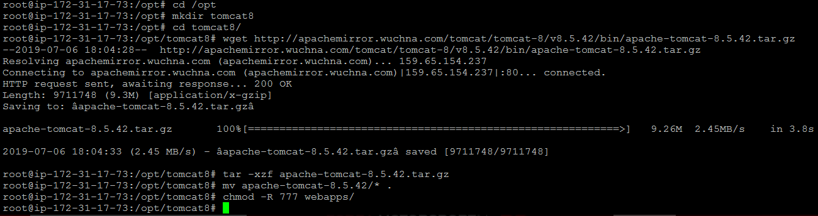

**Creating Jenkins pipeline script and configuring Jenkins job**

Now we need to create Jenkins pipeline script which will help us to automate complete CI/CD pipeline.

First login to Jenkins and create a new Jenkins pipeline job.

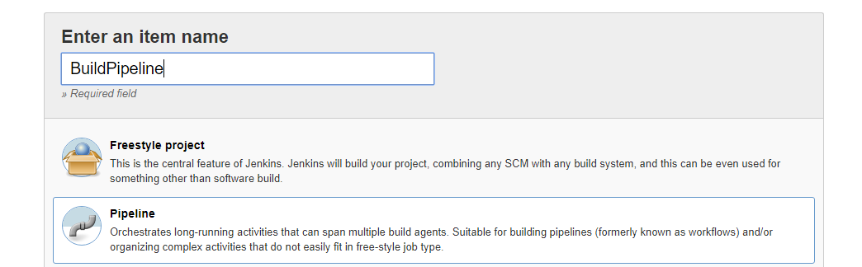

Then we need to configure pipeline script, we have to provide repository details from which we will be reading this pipeline script for running builds.

Use below Git repository link for configuring Pipeline job in Jenkins.

https://github.com/Anuj1990/MavenBuild.git

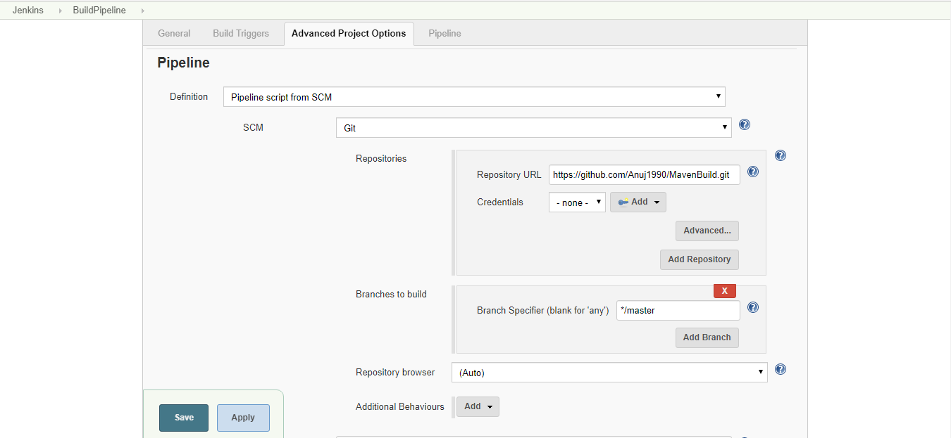

Once configuration is done we have to run the build using Build Now option. Once build is success we can validate that war artifact will be deployed to webapps directory in tomcat Apache.

